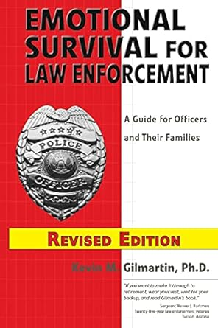

Emotional Survival for Law Enforcement: A Guide for Officers and Their Families

